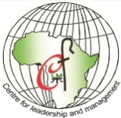
CENTRE FOR LEADERSHIP AND MANAGEMENT
TANGAZA UNIVERSITY COLLEGE

Our Mission Partners

PROGRAM FOR THE PROFESSIONAL

DEVELOPMENT

OF CONGREGATIONAL LEADERS (PDCL)

Supporting Women Religious

In Congregational Leadership

African-designed leadership programs

to meet changing global challenges

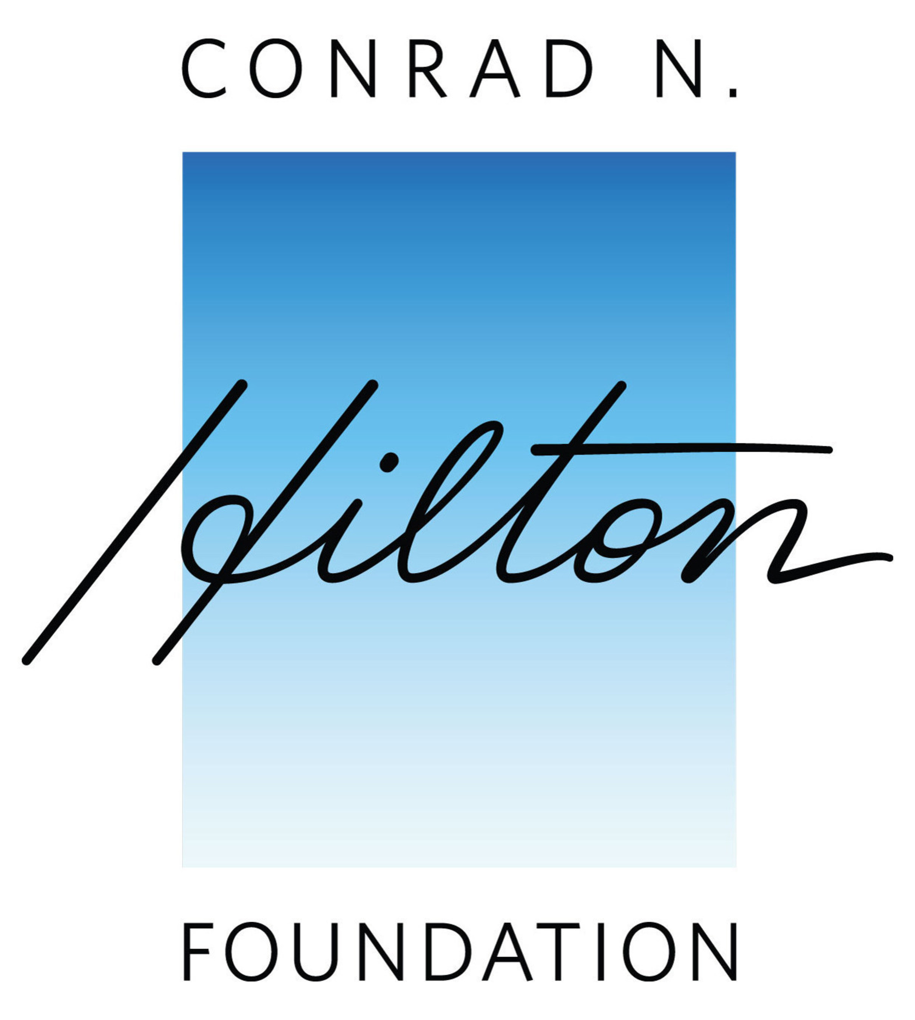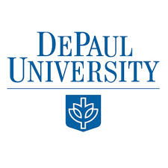

The Centre for Leadership and Management (CLM)

The purpose of the Centre for Leadership and Management is to prepare leaders for the African society who will uphold in their work places leadership based on the best of traditional African values and the Christian values of service, respect, and integrity. Value-centred leadership creates a public space where ethical standards are openly promoted and sustained.

Leadership and management are not the preserve of business and politics alone but are found in all organizations where people join to form a community with a common vision. Good leaders and managers serve in all occupations ranging from local authorities to health care services to small community projects. The Centre promotes the concept of Servant Leadership where the focus is service, not power or privilege for those who see leadership as a position of status.

Vision Statement

To be a world-class centre of excellence for leadership and management, committed to promoting life-long learning.

Mission Statement

To promote ethical, visionary and transformative leaders rooted in African and Christian values, appreciating the worth of prior learning and diversity of human experience; empowering the marginalized and supporting women leaders in Church and society and, preparing leaders capable of adapting to changing global trends.

Core values

In carrying out its mission, the Centre for Leadership and Management is committed to the following core values:
- Excellence in all its academic and social endeavours
- Competence and professionalism as the criteria for all appraisals and assessment.
- Integrity, transparency and accountability marking all academic studies and professional behaviour.
- Respect for cultural, social and religious diversity among faculty and students.
- Service to the community and advocacy on the part of the marginalized and those living in poverty.
- Innovation in responding to the changing educational needs of individuals and groups in a rapidly evolving world.
- Collaboration in learning through a programme of systematic mentoring.

Philosophy of CLM

The philosophy of CLM is based on the values, attitudes and practices of the Leadership tradition of St. Vincent de Paul (DePaul University: The Hay Project, Vincent on Leadership) and on the leadership ideals of African traditional communities. Both of these traditions of leadership stress the values of service, honesty and integrity, and the desire to maintain high ethical standards. These values are anchored in a spirituality of care and communion with others for the well-being of the society. CLM seeks to stimulate and develop in learners the creativity needed to enable them to reach their fullest potential through life-long learning skills, innovative and collaborative activities and respect for cultural diversity.

Academic Programmes

Programmes offered by the Centre for Leadership and Management
Certificate in Leadership and Management (2 trimesters):
Certificate in the Practice of Organizational Leadership (3 year cycle distance learning)
Diploma in Leadership and Management (4 trimesters
Diploma in Leadership and Resource Management: (4 semesters)
BA in Leadership and Management: (8 semesters)
MA in Ethics and Organizational Leadership (4 semesters)

PROFESSIONAL DEVELOPMENT PROGRAMME
FOR CONGREGATONAL LEADERS

This is an outreach programme under the care of CLM. Its purpose is to provide a local programme for women religious in congregational leadership. The Hilton Foundation has supported the three-year programme in which the sisters attended five modules with Faith and Praxis International and two modules with DePaul University – The Hay Project: Vincent on Leadership. These two institutions provided the experience, knowledge, skills and training necessary to begin a programme run by local sisters in congregational leadership. Some of the sisters who completed the training have become associates of CLM with whom they plan and present the programme.

Vision

Transforming church and society through the faith-filled and compassionate action of women religious in congregational leadership.
Mission

Professional Development for Congregational Leaders is a programme created in Africa for Africa which aims to ‘fan to flame’ the potential in leaders of women’s religious congregations to inspire and enable religious women-for-mission in today’s world.

Core Values

- Faith and creative fidelity
- Integrity and compassion
- Whole-hearted commitment to Church and humanity
- Networking and solidarity
Core Functions
- Offering opportunities for deepening self-knowledge and growth for both leaders and members
- Facilitating exchange and sharing of resources and collaborative action
- Exploring different ways to make decisions, solve problems and promote dialogue
- Developing approaches and competencies to deal with challenges within the organization, the Church and society
- Enabling in-depth exploration of the founding charism to respond to the African context.

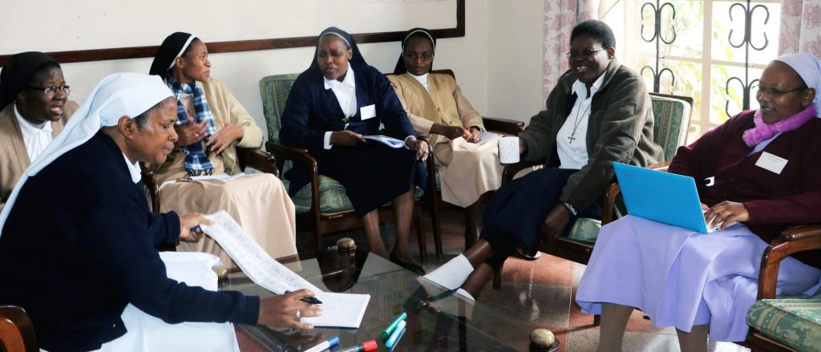
COMPETENCE STATEMENTS FOR CONGREGATIONAL LEADERSAND THEIR TEAMS

Part of the preparation in designing a local programme was the decision to work with DePaul University to articulate a set of competences, which would give direction to the desired outcomes. The following competencies, selected by a group of local congregational leaders are based on what they considered essential to their ministry:

Sister-Leaders as Servant Leaders
Sister-leaders as servant leaders can:
- put their faith and congregational charism into action;
- use principles of discernment in making decisions;
- demonstrate and inspire ethical standards rooted in gospel values;
- identify benefits of compassion and forgiveness for organizational renewal
Sister-Leaders as Strategic Influencers
Sister- Leaders as strategic influencers can:
- facilitate open communication of ideas;
- promote understanding of the cultural, historical and political context in which they are working and make informed decisions;
- assess the authority and responsibilities of a given role within an organization to move into that role effectively;
- promote an understanding of team-building and encourage collaboration to solve problems and make decisions;

Sister-Leaders as Stewards
Sister- leaders as stewards can:
- identify existing resources used to address inequalities and other problems in society, and manage them effectively.
- inspire and set a clear vision and direction of the organization
- use the dynamics of managing change to enable a community to retain clarity of mission while undergoing the process of change.
- define and implement a process for discerning a mission within emerging options.

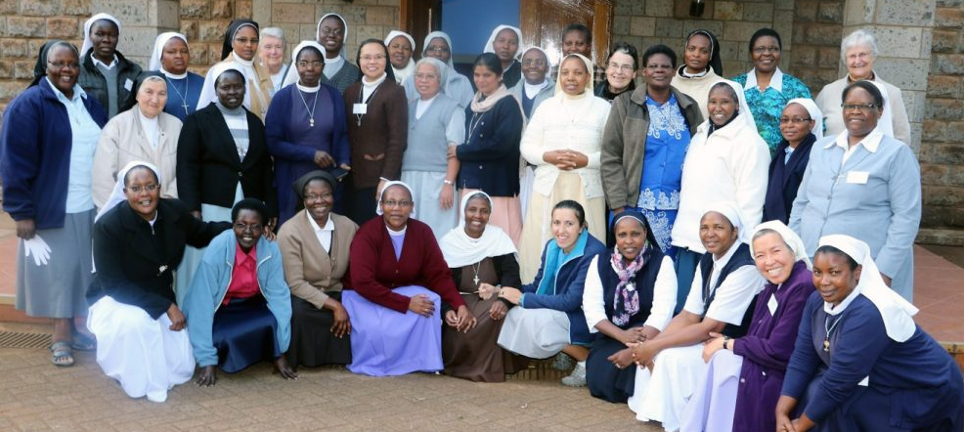

The duration of the certificate is based on a two-year cycle so that leaders can plan to attend well ahead of time and be equipped with the leadership skills the programme provides during their term of office (3 years for the majority).

- The Three Modules
Module 1: Developing the Leader Within.
Module 2: Creating a Faith-filled Congregational Culture.
Module 3: Leadership for Mission.

- Content of Module 1
Organization as a Living System /Charism Tree
Generational leadership views, values and styles.
Stages of team development: signs of dysfunction in a team.
Transformative Experience Framework: context, system, person and faith (an analytical tool) Praxis events
Self-awareness as a person: multiple intelligences; emotional intelligence; the brain.
The African experience of leadership.
Power and Authority
ii.i. Action-Reflection Weekend Session – 6 months after Module 1 – Sharing and review of Learning Summaries

- Content of Module 2
Role of Provincial
Role of Councilor / Team members – Dysfunctional Councils
The role of the Provincial in building an Organizational Culture
Making a Plan for Animation of a Province
Intercultural Living in a Religious Congregation
Theological Reflection
Conflict and Confrontation
Compassion & Forgiveness in a Religious Congregation
Coaching
Contemplative Dialogue

- Content of Module 3
Reading the Signs of the Times - Global Trends PPt
Consecrated Life for Mission: Pope Francis Prophecy and Mission: Scriptural basis of Prophecy
Organization in the Mind
Theory U as a Framework for Profound Change
Value clarification
Personal & Communal Discernment
Social Teachings of the Church
Sustainable Development Goals and the Sisters’ Mission
Mission versus Ministry, Mission vs. Business
Human Cost of Mission
Contemplative Dialogue
Celebrating the Mission of Sisters

While maintaining core themes, the content of the Modules meant to respond to the current needs of Congregational leaders will undergo ongoing evaluation and updating.

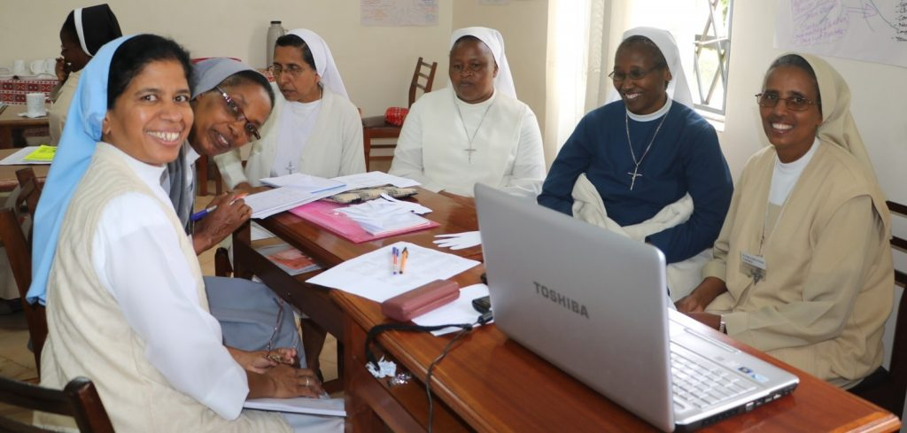

PDCL Learning Process
Adult Learning: Learning from Experience
- The aim of the Event is to work at the fusion of theory and experience by using actual situations Sister-Leaders encounter in their role as leaders of religious congregations. Handouts will be given to support the learning
- PowerPoint presentations, used in the module, will be made available. If participants bring their flash drive, the presentations can be copied on the last day

Learning Tools:
- Log Book
- Learning Group
- Learning Summaries
- Practical Application Events and Praxis Events in between the Modules

Base Group
Participants who are geographically close are encouraged to form a base group where they support one another through the sharing of personal reflections and praxis events. Forming a WhatsApp Base Group is another possibility.

Action-Reflection Session between Modules 1 & 2:
The process of making use of the skills and the knowledge you learned during the Modules, is an indispensable part of your learning and is a requirement of the Hilton Grant. The provision of the grant depends on the evidence you provide of your learning. The programme invites you to write up one of these events and think about it by answering the reflection questions below. This kind of reflection-action-reflection very much fosters a deeper assimilation and mastery of the material.
GUIDELINE FOR LEARNING SUMMARY
- Prepare an event that you will conduct in your community/province that would demonstrate a skill learned in the Module. This would also include the evaluation of the event by the participants (see evaluation guide).
- Write your reflection on one of the topics that has touched your life and can help you grow as a leader.
- Only those who complete the modules and the learning summaries, as well as attend a base group meeting/action reflection weekend will receive the Certificate in the Practice of Organizational Leadership (CPOL) which will indicate the competencies gained.

FORMAT FOR REPORT ON THE LEARNING SUMMARY

- Practical Application
Write a description (two sides of A4) of the event you conducted to achieve the leadership competences you had chosen to work on.
This could be about a meeting or an event which you organised, or an account of the way you worked with your Council / Team.
- To enable you to reflect on the experience, answer the following:
- The Event: describe it, its objective. Indicate who was involved and what activities you organized?
- Observation and Reflection: What did you notice? What happened, what were your observations?
- Forming Generalizations: What ideas did you learn about the competences and working to achieve them?
- Applying the Learnings: What implications has your learning for other contexts?

- Summary of the Evaluation of the event* from the participants

*FOR THE EVALUATION OF YOUR EVENT by the participants to your session. You may use the evaluation questions below for your participants to complete after your session with them.
Summarise of the responses of your participants in your Learning Summary:
- Something new I learned from this session is…
- Something from this session I can use for my work is (also say how you would go about using it)…
- I would like more input or training on….

Requirements for the Certificate:
- Attend the three Modules
- Complete the Learning Summaries between Modules 1 & 2
- Attend the Weekend of Action-Reflection after Module 1

The Certificate in the Practice of Organizational Leadership (CPOL) will indicate the topics the recipient studied and applied concerning leadership skills and knowledge. Those awarded the certificate can apply to CLM to train as Associates of the PDCL.
Sisters who do not apply any of their learning and complete their learning summaries but who simply attend the three Modules receive a Certificate of Participation.
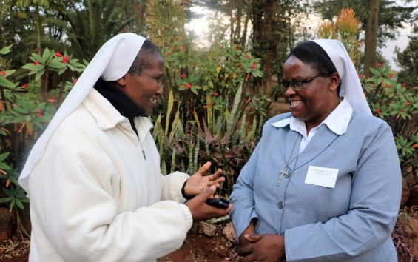
The structure of the programme developed by the Centre for Leadership and Management is as follows:
PDCL
Associates
The CLM administration will form the Board for the Professional Development of Congregational Leaders programme. The sisters who are the trained facilitators will become associates of CLM.
Criteria for becoming associates:
- Attend and complete the tasks of the three Modules.
- Undertake the training sessions for facilitators.
- Be available for facilitating different sessions of the Modules.
- Be free to attend planning sessions before the Module.
- Have experience in leadership.

Letter of appointment
Sisters who have accepted the invitation to become associates will receive a letter of appointment for one year, renewable annually.

Training sessions for each module
Before each module there will be three (3) training sessions:
- Allocation of tasks and adjustments to areas being presented.
- Sharing of proposed format and content of topic.
- Before the module, a practice session for associates to share their prepared presentations with one another.
Remuneration for Services
The attendance at meetings for planning and training and the facilitation of sessions will be paid according to Tangaza University rates.
The Assistant coordinator will receive an amount to be proportionate to her duties and time commitment.
Marketing
An important contribution expected of the associates is their encouraging sisters in leadership to attend the modules.

Additional Services:

Coaching Training
In conjunction with The Leaders Guild interested participants will be trained in coaching. This service given ‘sister to sister’ could be a support especially for women religious who find themselves in geographically isolated places, or in need of a ‘listening and discerning ear’ they can trust.

Consultation
Custom-designed programmes for particular congregations and organizations are foreseen as an additional service for the near future as the need would arise.

From the Conrad Hilton Foundation – Why Catholic Sisters are a priority:
Catholic sisters contribute to human development through their spiritual witness and service to those in need. More than 700,000 sisters around the world educate our children, care for the vulnerable, stand with the oppressed, promote peace, and advocate for justice. Like our founder, Conrad N. Hilton, we recognize sisters as resourceful, efficient, and powerful agents of social change.

